**Exploratory Analysis on CitiBike**

The Citi Bike Program has implemented a robust infrastructure for collecting data on the program's utilization, since 2013. The dataset that was considered for the exploratory analysis is the first quarter of 2021 to uncover hidden trends or patterns, so give a heads up for the company for future planning and strategies.

The analysis of the dataset shows several patterns, based on several factors of the Citibike users. The following are the analysis on the various factors.

**1. CitiBike Quarterly Analysis Q1 2021 - User type Analysis**

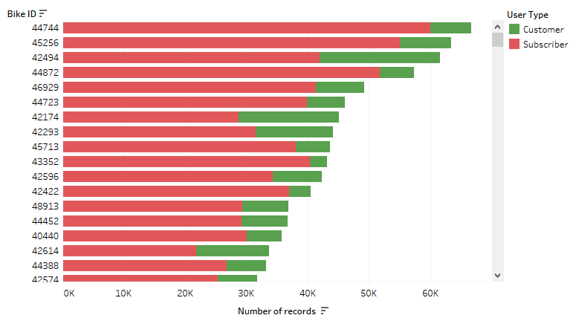The User type of Citi bike users consists of two categories, namely, Customer and Subscriber. The first quarter analysis of the User type shows that the Subscribers have consistently high usage of the service compared to the customers who use the service on a need-on-basis.

**2. CitiBike Quarterly Analysis Q1 2021 - Birth Year Analysis**

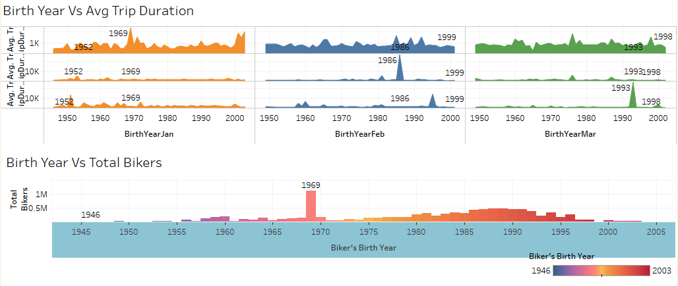The dashboard consisting of Birth year data is created to show the relation between the customer age and the average trip duration covered and the total count of bikers. It was found that the bikers with birth year, 1999 have been higher in the all the three months.

The overall total usage of the service is high in the users who were born in the late 60s. Though the trip duration is lower in this age category, the number of users is the highest.

**3. CitiBike Quarterly Analysis Q1 2021 - Average Trip Duration**

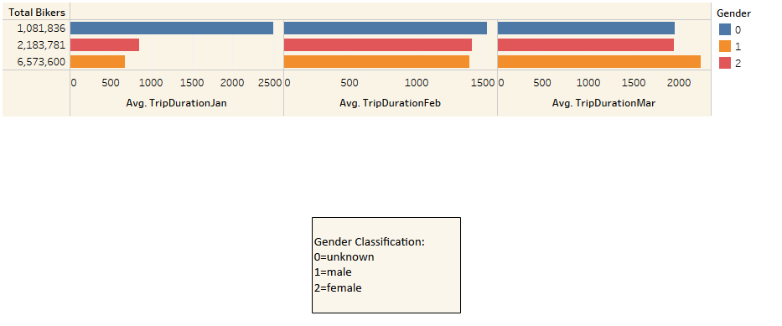The analysis was made to arrive at the average trip duration in the first quarter based on the count of customer's gender. The three categories for the gender classification is 0-unknown, 1-male and 2-female. It was found that most of the users did not specify the gender and the users who did specify had the most usage among female in January and February months and men were the leading users in March.

**4. CitiBike Quarterly Analysis Q1 2021 - Busy Stations Jan**

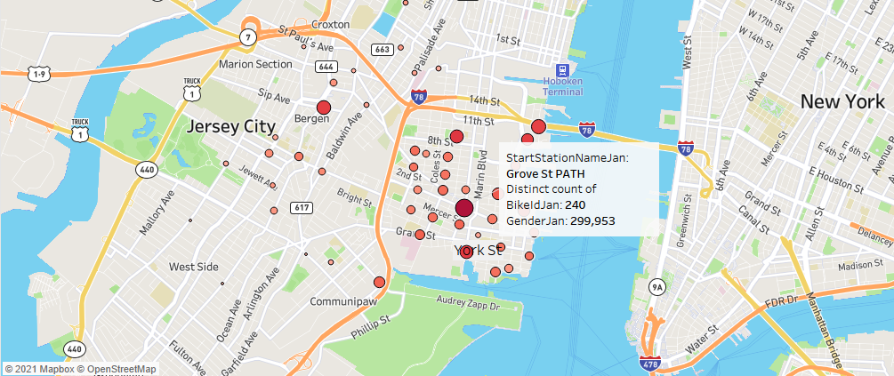

The geo plot of the stations in Jersey City revealed that the busiest station in the month of January was the one in Grover Street Path with a total of 299,953 users. The size of the circles shows the stations in order of highest usage.

**5. CitiBike Quarterly Analysis Q1 2021 - Busy Stations Feb**

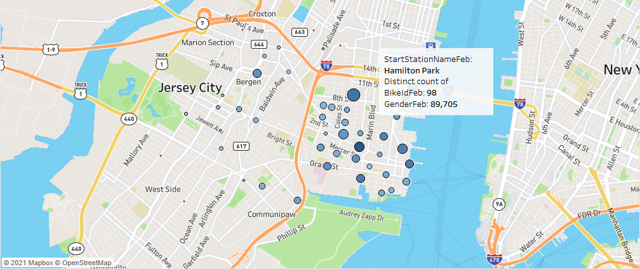

The geo plot of the stations in Jersey City revealed that the busiest station in the month of February was the same as the previous month, that is in Grover Street Path with a total of 89,705 users. The size of the circles shows the stations in order of highest usage.

**6. CitiBike Quarterly Analysis Q1 2021 - Busy Stations Mar**

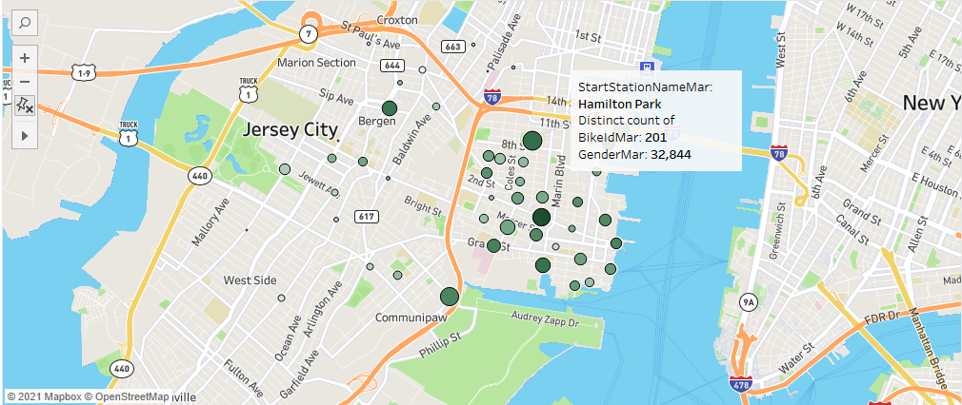

The geo plot of the stations in Jersey City revealed that the busiest station in the month of March was in Hamilton Park with a total of 32,844 users. The size of the circles shows the stations in order of highest usage.

It can be observed that the usage gradually decreased in the past two months. This could be attributed to the dip in weather conditions, which may have discouraged the bike riders.

**7. CitiBike Quarterly Analysis Q1 2021 - Peak Hours**

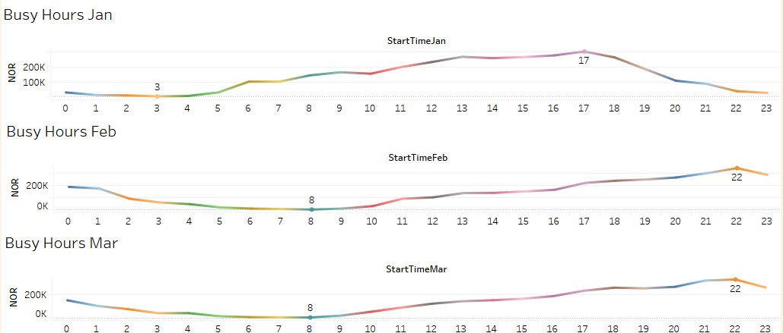

An analysis was made to reveal the busiest hours during which most of the bikes are ridden in the city. It was found that late evening are the preferred time for most of the riders to use the service.